1. Is Airbnb ‘out of control’ in London?
Airbnb was founded in 2008. With the original intention of sharing idle housing resources, landlords are allowed to rent vacant rooms or apartments for a short time. At the same time, it provides more flexible, economical and localised accommodation options for tourists. However, in recent years in London, the development of this platform has gradually deviated.
Figure 1
The number of Airbnb houses increases each year
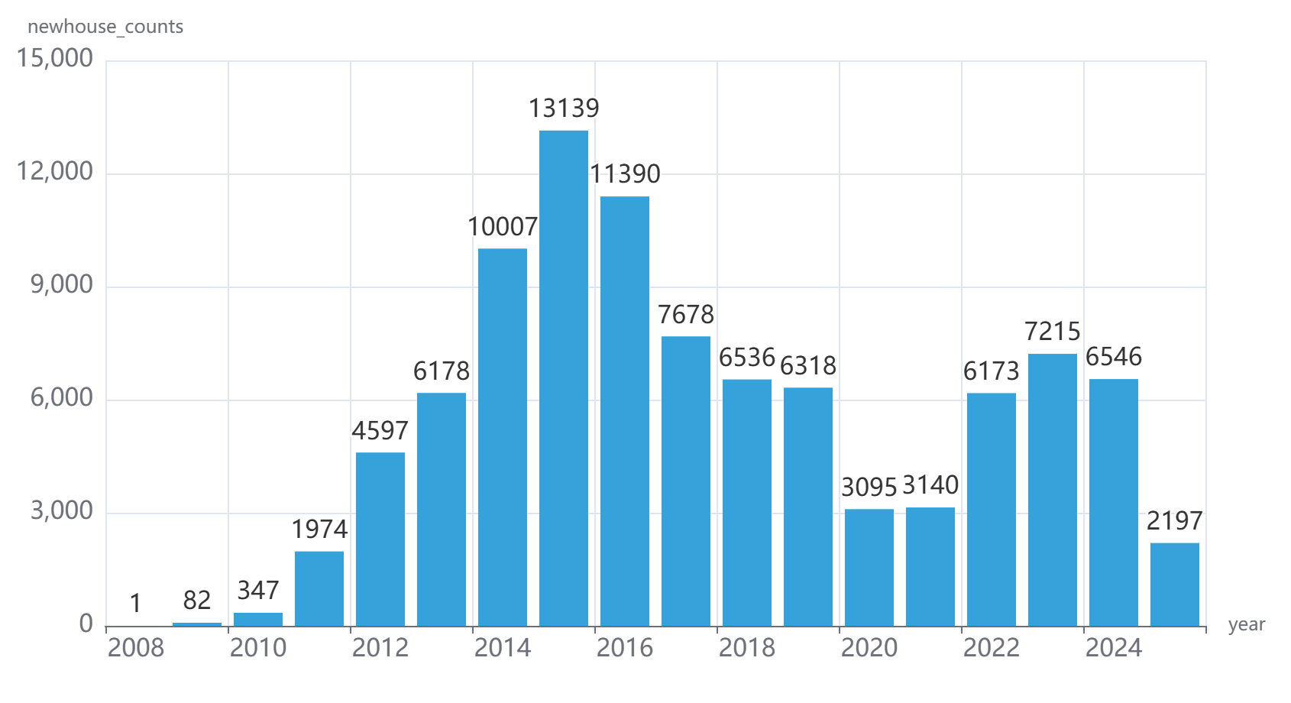
In the past fifteen years, the number of Airbnb housing in London has shown explosive growth. Among them, the whole set of rental housing resources is particularly prominent. By June 2025, there have been about 60,000 units, accounting for as high as 64.62%. In most European cities, the proportion of whole rental housing resources exceeds 50%, which shows that commercialisation is obvious. This shows that London has become a highly commercialised city. Even assuming that only 40% of the whole rental source is alternative in the traditional rental market, it means that about 25,000 houses are removed from the long-term rental market.
Figure 2
The proportion of different room types in the total number of houses
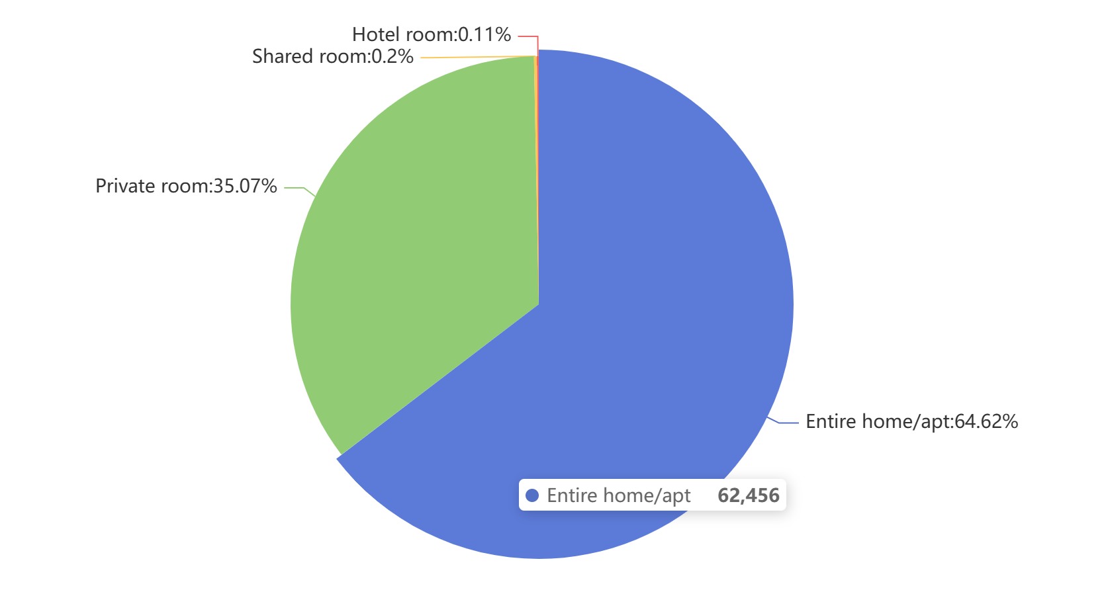
Some landlords own more than one set of housing units, and some even have more than 400 sets. The number of housing resources they have accounts for most of the total housing resources, and they are the core group that promotes commercialisation. This means that the rental of houses is no longer just an occasional sharing, but a profit-dominated business.
Figure 3
The proportion of landlords with different levels of houses
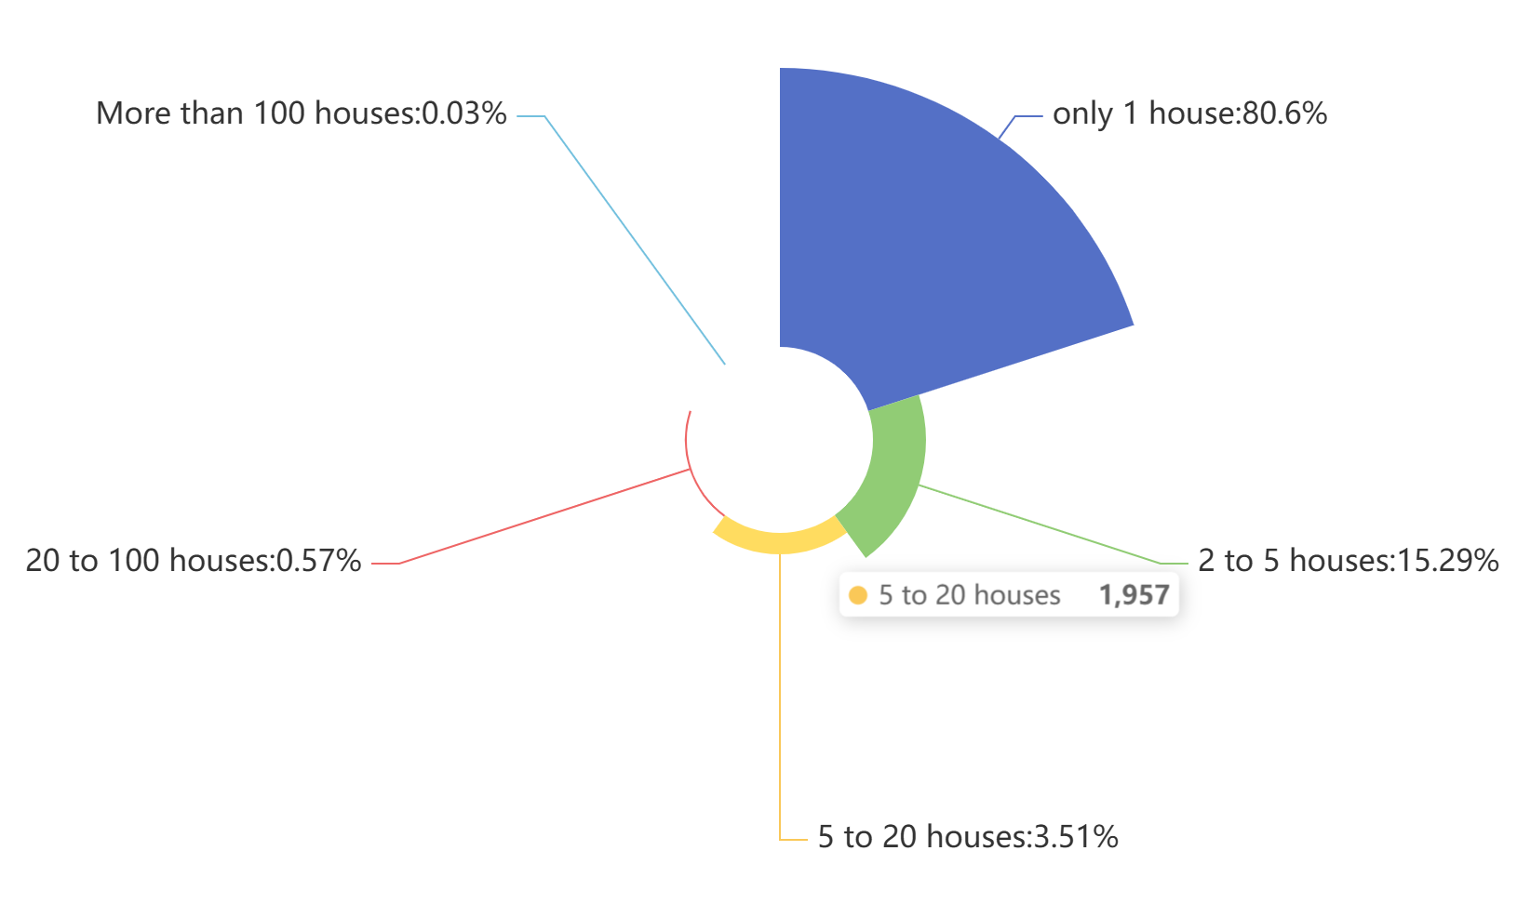
Airbnb properties in London are mainly concentrated in Westminster, Tower Hamlets, Kensington and Chelsea, Camden and other areas. These are all popular tourist areas with the highest rent and the tightest housing demand. In these areas, Airbnb housing has had an impact on the original housing market. This trend shows that Airbnb has become highly centralised and specialised in some popular tourist areas and downtown areas.
Figure 4
The number of airbnb listings in different areas of London
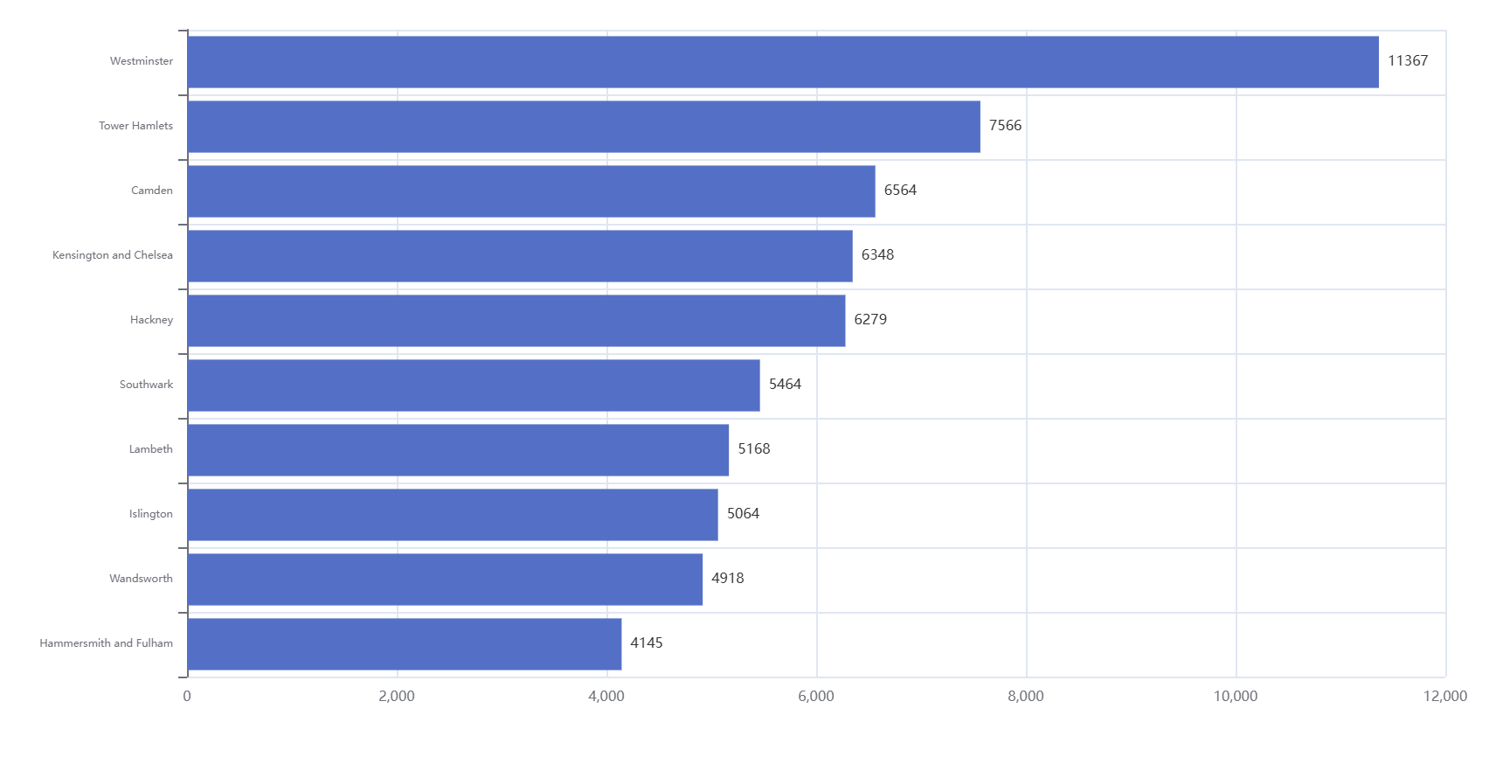
This commercial expansion has put significant pressure on London's long-term rental market. The whole apartment is used for short-term rental, reducing the housing resources that could be rented for local residents for a long time. As a result, rents in some areas continue to rise, putting greater housing pressure on the working class, young people and families. At the same time, short-term rental residents with high mobility rates also have an impact on the stability of the community, and neighbourhood relations, life order and safety are disturbed to a certain extent. Although Airbnb has brought considerable economic benefits, including tourism revenue, food and service stimulus, and additional revenue from landlords, this distribution of benefits is uneven. However, the potential social and market costs are obviously concentrated in long-term tenants and community residents.
From a policy perspective, London already has measures such as short-term rental restrictions of "90 days a year". However, it is difficult to implement, and some landlords adopt strategies to avoid supervision. Therefore, Airbnb does show a "out of control" state in some areas and some housing types in London, especially the growth of whole rental commercialisation and the impact on the long-term rental market.
Nevertheless, there is still room for regulation in the whole market. The government can differentiate taxes, limit the number of short-term rental days, encourage long-term lease return, and strengthen regulatory transparency. It is still possible to strike a balance between protecting residents' housing rights and promoting a short-term rental economy.
Therefore, Airbnb's "out of control" is more local and structural, not completely unmanageable. The key is how policymakers design reasonable regulatory and incentive mechanisms to ensure that the sharing economy can truly benefit local residents and communities.

